Abstract:

Pneumonia is a life-threatening bacterial illness caused by Streptococcus pneumoniae bacterium that affects one or both lungs in humans. .Expert radiotherapists are required to evaluate chest X-rays used to diagnose pneumonia. As a result, establishing an autonomous method for identifying pneumonia would be advantageous for quickly treating the condition, especially in distant places. Convolutional Neural Networks (CNNs) have received a lot of interest for illness categorization due to the effectiveness of deep learning algorithms in evaluating medical imagery. In this work, we use different classifiers for the training and compare these models with different metrics to find the better model for completing the task.

Introduction:

Deep learning techniques rely on neural networks, which are a subset of machine learning. They're made up of node levels, each of which has an input layer, one or more hidden layers, and an output layer. Each node is connected to the others and has a weight and threshold assigned to it. If a node's output exceeds a certain threshold value, the node is activated, and data is sent to the next tier of the network. Otherwise, no data is sent on to the networks next tier .A convolution network is basically designed based on our neural networks in the brain. Convolutional Neural Networks (CNNs) are inspired by the brain's visual cortex and are used to tackle complex image-driven pattern recognition problems, such as identifying linear and non-linear patterns [1].CNNs are advantageous for image classification because they require fewer parameters and connections. In comparison to other neural networks, this makes training such neural networks (CNNs) easier. Artificial Neural Networks, on the other hand, struggle with picture data processing due to the high level of computational complexity involved. [1]

Methodology:

For this problem we use three different classifiers like vgg16, vgg19, Resnet50 and a simple convolution networks.

At we use a normal CNN consisting of input layer

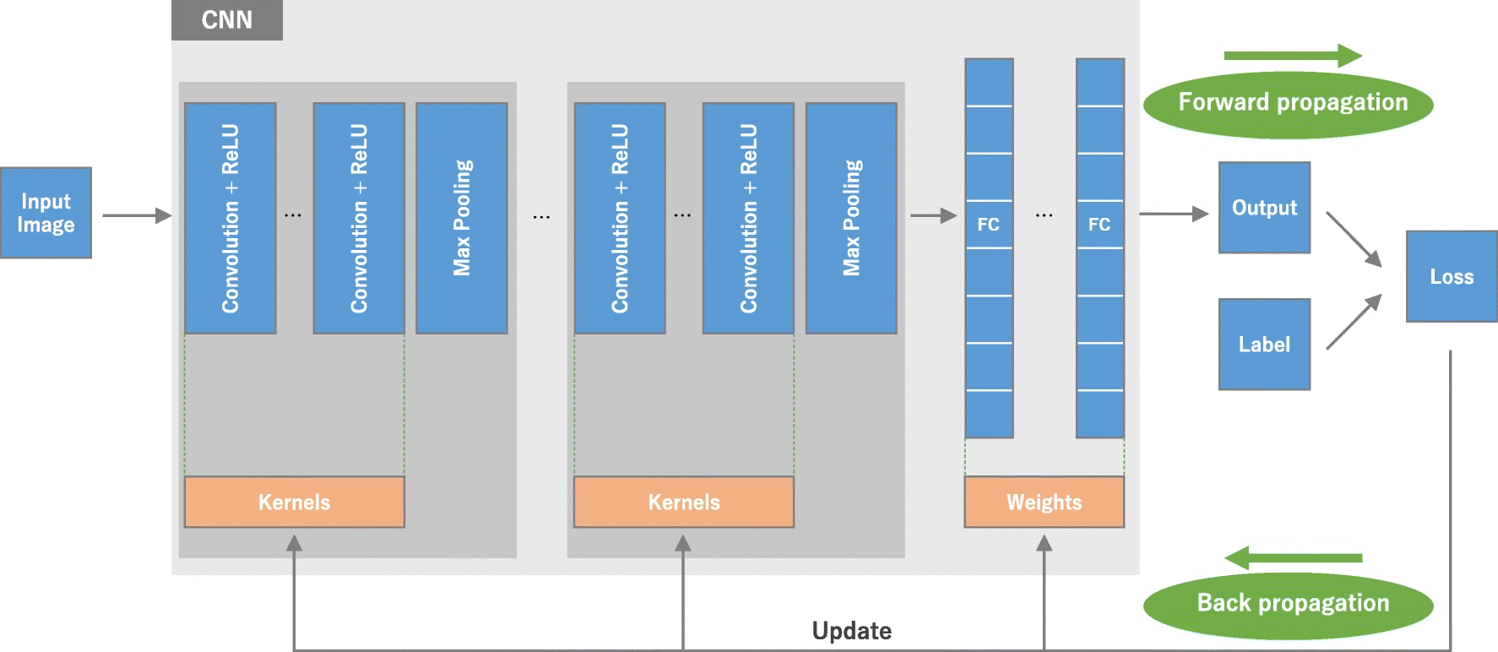

_______________________________________________________________

1.Jain, R., Nagrath, P., Kataria, G., Kaushik, V.S. and Hemanth, D.J., 2020. Pneumonia detection in chest X-ray images using convolutional neural networks and transfer learning. *Measurement*, *165*, p.108046.